**Spring Data JPA Handson**

**Create a Eclipse Project using Spring Initializr**

**Program:**

**Country.java**

package com.cognizant.orm_learn.model;

import jakarta.persistence.Entity;

import jakarta.persistence.Table;

import jakarta.persistence.Column;

import jakarta.persistence.Id;

@Entity

@Table(name="country")

public class Country {

public Country() {

super();

}

public Country(String code, String name) {

super();

this.code = code;

this.name = name;

}

@Id

@Column(name = "co_code")

private String code;

@Column(name = "co_name")

private String name;

public String getCode() {

return code;

}

public void setCode(String code) {

this.code = code;

}

public String getName() {

return name;

}

public void setName(String name) {

this.name = name;

}

@Override

public String toString() {

return "Country [code=" + code + ", name=" + name + "]";

}

}

**CountryRepository.java**

package com.cognizant.orm_learn.repository;

import org.springframework.data.jpa.repository.JpaRepository;

import org.springframework.stereotype.Repository;

import com.cognizant.orm_learn.model.Country;

@Repository

public interface CountryRepository extends JpaRepository<Country, String> {

}

**CountryService.java**

package com.cognizant.orm_learn.service;

import org.springframework.beans.factory.annotation.Autowired;

import org.springframework.stereotype.Service;

import com.cognizant.orm_learn.model.Country;

import com.cognizant.orm_learn.repository.CountryRepository;

import java.util.List;

@Service

public class CountryService {

@Autowired

private CountryRepository countryRepository;

public List<Country> getAllCountries() {

return countryRepository.findAll();

}

}

**Application.properties:**

spring.application.name=orm-learn

# Logging

logging.level.org.springframework=info

logging.level.com.cognizant=debug

logging.level.org.hibernate.SQL=trace

logging.level.org.hibernate.type.descriptor.sql=trace

logging.pattern.console=%d{dd-MM-yy} %d{HH:mm:ss.SSS} %-20.20thread %5p %-25.25logger**{25}** %25M %4L %m%n

# DB Connection

spring.datasource.driver-class-name=com.mysql.cj.jdbc.Driver

spring.datasource.url=jdbc:mysql://localhost:3306/ormlearn

spring.datasource.username=root

spring.datasource.password=password

# Hibernate

spring.jpa.hibernate.ddl-auto=validate

spring.jpa.properties.hibernate.dialect=org.hibernate.dialect.MySQLDialect

**OrmLearnApplication.java**

package com.cognizant.orm_learn;

import java.util.List;

import org.slf4j.Logger;

import org.slf4j.LoggerFactory;

import org.springframework.boot.SpringApplication;

import org.springframework.boot.autoconfigure.SpringBootApplication;

import org.springframework.context.ApplicationContext;

import com.cognizant.orm_learn.model.Country;

import com.cognizant.orm_learn.service.CountryService;

@SpringBootApplication

public class OrmLearnApplication {

private static CountryService countryService;

private static final Logger LOGGER = LoggerFactory.getLogger(OrmLearnApplication.class);

private static void testGetAllCountries() {

LOGGER.info("Start");

List<Country> countries = countryService.getAllCountries();

LOGGER.debug("countries={}", countries);

LOGGER.info("End");

}

public static void main(String[] args) {

ApplicationContext context = SpringApplication.run(OrmLearnApplication.class, args);

countryService = context.getBean(CountryService.class);

LOGGER.info("Inside main");

testGetAllCountries();

}

}

**Creating a database with Country table and inserting values:**

create schema ormlearn;

create table country(co_code varchar(2) primary key, co_name varchar(50));

insert into country values ('IN', 'India');

insert into country values ('US', 'United States of America');

Output:

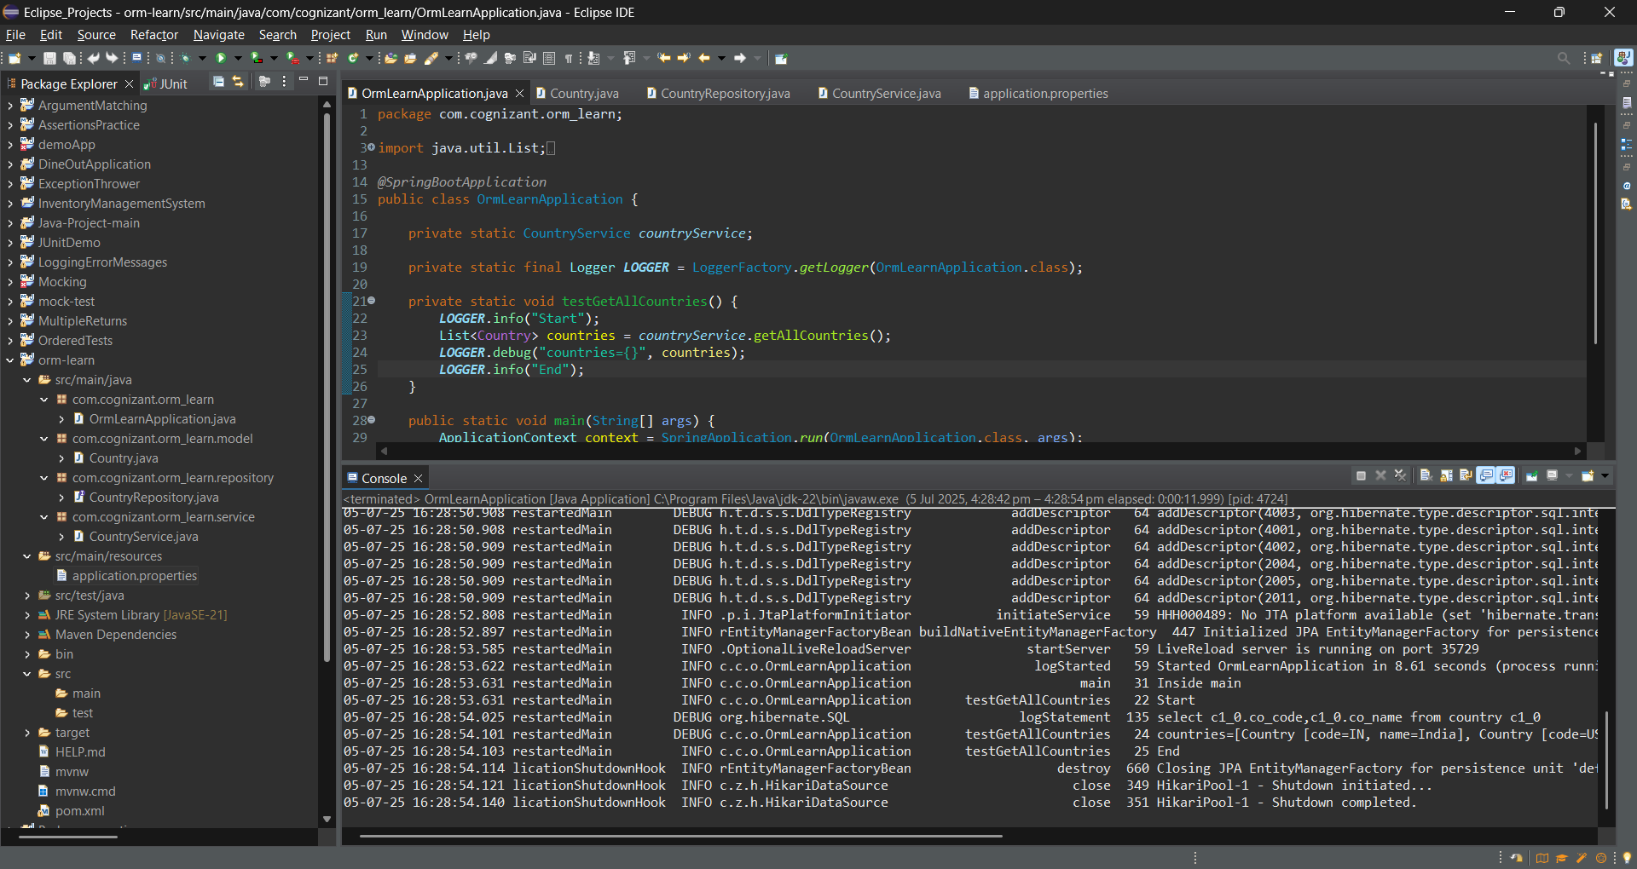

**Hands on 2**

**Hibernate XML Config implementation walk through**

**Explain how object to relational database mapping done in hibernate xml configuration file**

Hibernate maps Java classes to database tables using XML Configuration.

**Example:**

**Employee.hbm.xml**

<hibernate-mapping>

<class name="Employee" table="EMPLOYEE">

<id name="id" column="id">

<generator class="native"/>

</id>

<property name="firstName" column="first_name"/>

<property name="lastName" column="last_name"/>

<property name="salary" column="salary"/>

</class>

</hibernate-mapping>

**Explanation:**

<class> maps the Java class to the DB table.

<id> maps the primary key.

<property> maps the fields to columns.

**Explain about following aspects of implementing the end to end operations in Hibernate:**

**SessionFactory:**

A factory for Session objects.

It's a heavyweight object created once per application.

It manages database connections and Hibernate configurations.

Usage:

SessionFactory factory = new Configuration()

.configure("hibernate.cfg.xml")

.addResource("Employee.hbm.xml")

.buildSessionFactory();

**Session:**

A single-threaded, lightweight object used to interact with the database.

It acts as a bridge between Java code and DB operations.

It is used for performing CRUD (Create, Read, Update, Delete) operations.

Usage:

Session session = factory.openSession();

**Transaction:**

It represents a unit of work done in a session.

It wraps multiple operations in a single atomic unit.

It also ensures data integrity with commit or rollback.

Usage:

Transaction tx = session.beginTransaction();

**beginTransaction():**

Transaction tx = session.beginTransaction();

This prepares the session to perform safe DB operations and keeps track of changes.

**commit():**

It saves permanently in Database.

Once called, all operations inside the transaction are made permanent in the database.

Usage:

tx.commit();

**rollback():**

Reverts changes in case of failure:

Used inside exception blocks to avoid partial writes or inconsistent data.

Usage:

tx.rollback();

**session.save()**

Saves a new Object in the database.

Hibernate assigns a primary key and inserts the record.

Example:

Employee emp = new Employee("John", "Doe", 50000);

session.save(emp);

**session.createQuery().list():**

Retrieves data from the database.

createQuery() accepts HQL (Hibernate Query Language).

.list() executes the query and returns a list of objects.

**session.get()**

Fetches a specific object by primary key.

Returns the persistent object or null if not found.

Performs a DB hit immediately.

Example:

Employee emp = session.get(Employee.class, 1);

**session.delete():**

Deletes an object from the database.

This removes the corresponding record from the database.

Example:

Employee emp = session.get(Employee.class, 1);

session.delete(emp);

**Hands on 3**

**Hibernate Annotation Config implementation walk through**   
Explain how object to relational database mapping done in persistence class file Employee

Hibernate uses annotations in the Java class (like Employee) to map object fields to database table columns.

Example:

@Entity

@Table(name = "employee")

public class Employee {

@Id

@GeneratedValue(strategy = GenerationType.IDENTITY)

private int id;

@Column(name = "name")

private String name;

@Column(name = "email")

private String email;

}

**Explain about following aspects of implementing the end to end operations in Hibernate:**

**@Entity**

1. Marks a class as a Hibernate entity (a table in DB).
2. Required for Hibernate to recognize and persist the class.
3. Must have a no-arg constructor and at least one @Id.

**@Table**

1. Specifies the table name to which the entity is mapped.
2. Optional if class name matches the table name.
3. Can define schema and catalog (e.g., @Table(name = "emp", schema = "hr")).

**@Id**

1. Marks a field as the **primary key** of the entity.
2. Must be unique and not null.
3. Required for every entity class.

**@GeneratedValue**

1. Specifies how the primary key value is generated.
2. Common strategies: AUTO, IDENTITY, SEQUENCE, TABLE.
3. Used in conjunction with @Id.

**@Column**

1. Maps a field to a specific column in the table.
2. Can specify name, length, nullable, unique, etc.
3. Optional if field name matches column name.

**Hibernate Configuration (hibernate.cfg.xml)**

**hibernate.dialect**

1. Tells Hibernate how to generate SQL for a specific DB.
2. Example: org.hibernate.dialect.MySQLDialect.
3. Optimizes SQL for the target DB.

**hibernate.connection.driver_class**

1. JDBC driver class to connect to the DB.
2. Example: com.mysql.cj.jdbc.Driver.
3. Must match the DB you're using.

**hibernate.connection.url**

1. Specifies the DB location.
2. Format: jdbc:<db>://<host>:<port>/<dbname>.
3. Example: jdbc:mysql://localhost:3306/test.

**hibernate.connection.username**

1. DB login username.
2. Must have permission to read/write in the DB.
3. Example: root.

**hibernate.connection.password**

1. Password for the DB username.
2. Stored in plain text (in dev only).
3. Example: root123.

**Hands on 4**

**Difference between JPA, Hibernate and Spring Data JPA**   
**Java Persistence API (JPA)**

1. Specification for object-relational mapping (ORM) in Java.
2. Defines interfaces, not implementations (e.g., EntityManager, @Entity, etc.).
3. Hibernate is one of its most popular implementations.

**Hibernate**

1. A concrete implementation of the JPA specification.
2. Also provides additional features beyond JPA (like caching, lazy loading strategies, etc.).
3. Manages DB operations via Session, Transaction, etc.

**Example (Hibernate):**

Session session = factory.openSession();

Transaction tx = session.beginTransaction();

session.save(employee);

tx.commit();

session.close();

**Spring Data JPA**

1. Built on top of JPA/Hibernate to reduce boilerplate code.
2. Offers CRUD operations, custom queries, and pagination out-of-the-box.
3. Uses interfaces like JpaRepository<Employee, Integer> and annotations like @Transactional.

**Example (Spring Data JPA):**

@Autowired

EmployeeRepository employeeRepository;

@Transactional

public void addEmployee(Employee emp) {

employeeRepository.save(emp);

}

**Hands on 5**

**Implement services for managing Country**   
An application requires for features to be implemented with regards to country. These features needs to be supported by implementing them as service using Spring Data JPA.

* Find a country based on country code
* Add new country
* Update country
* Delete country
* Find list of countries matching a partial country name

Before starting the implementation of the above features, there are few configuration and data population that needs to be incorporated. Please refer each topic below and implement the same.   
  
**Explanation for Hibernate table creation configuration**

* Moreover the ddl-auto defines how hibernate behaves if a specific table or column is not present in the database.
  + create - drops existing tables data and structure, then creates new tables
  + validate - check if the table and columns exist or not, throws an exception if a matching table or column is not found
  + update - if a table does not exists, it creates a new table; if a column does not exists, it creates a new column
  + create-drop - creates the table, once all operations are completed, the table is dropped

# Hibernate ddl auto (create, create-drop, update, validate)

spring.jpa.hibernate.ddl-auto=validate

**Populate country table**

**Delete all the records in Country table:**

truncate table country;

**Populating the Country table:**

insert into country (co_code, co_name) values ("AF", "Afghanistan");

insert into country (co_code, co_name) values ("AL", "Albania");

insert into country (co_code, co_name) values ("DZ", "Algeria");

insert into country (co_code, co_name) values ("AS", "American Samoa");

insert into country (co_code, co_name) values ("AD", "Andorra");

insert into country (co_code, co_name) values ("AO", "Angola");

insert into country (co_code, co_name) values ("AI", "Anguilla");

insert into country (co_code, co_name) values ("AQ", "Antarctica");

insert into country (co_code, co_name) values ("AG", "Antigua and Barbuda");

insert into country (co_code, co_name) values ("AR", "Argentina");

insert into country (co_code, co_name) values ("AM", "Armenia");

insert into country (co_code, co_name) values ("AW", "Aruba");

insert into country (co_code, co_name) values ("AU", "Australia");

insert into country (co_code, co_name) values ("AT", "Austria");

insert into country (co_code, co_name) values ("AZ", "Azerbaijan");

insert into country (co_code, co_name) values ("BS", "Bahamas");

insert into country (co_code, co_name) values ("BH", "Bahrain");

insert into country (co_code, co_name) values ("BD", "Bangladesh");

insert into country (co_code, co_name) values ("BB", "Barbados");

insert into country (co_code, co_name) values ("BY", "Belarus");

insert into country (co_code, co_name) values ("BE", "Belgium");

insert into country (co_code, co_name) values ("BZ", "Belize");

insert into country (co_code, co_name) values ("BJ", "Benin");

insert into country (co_code, co_name) values ("BM", "Bermuda");

insert into country (co_code, co_name) values ("BT", "Bhutan");

insert into country (co_code, co_name) values ("BO", "Bolivia, Plurinational State of");

insert into country (co_code, co_name) values ("BQ", "Bonaire, Sint Eustatius and Saba");

insert into country (co_code, co_name) values ("BA", "Bosnia and Herzegovina");

insert into country (co_code, co_name) values ("BW", "Botswana");

insert into country (co_code, co_name) values ("BV", "Bouvet Island");

insert into country (co_code, co_name) values ("BR", "Brazil");

insert into country (co_code, co_name) values ("IO", "British Indian Ocean Territory");

insert into country (co_code, co_name) values ("BN", "Brunei Darussalam");

insert into country (co_code, co_name) values ("BG", "Bulgaria");

insert into country (co_code, co_name) values ("BF", "Burkina Faso");

insert into country (co_code, co_name) values ("BI", "Burundi");

insert into country (co_code, co_name) values ("KH", "Cambodia");

insert into country (co_code, co_name) values ("CM", "Cameroon");

insert into country (co_code, co_name) values ("CA", "Canada");

insert into country (co_code, co_name) values ("CV", "Cape Verde");

insert into country (co_code, co_name) values ("KY", "Cayman Islands");

insert into country (co_code, co_name) values ("CF", "Central African Republic");

insert into country (co_code, co_name) values ("TD", "Chad");

insert into country (co_code, co_name) values ("CL", "Chile");

insert into country (co_code, co_name) values ("CN", "China");

insert into country (co_code, co_name) values ("CX", "Christmas Island");

insert into country (co_code, co_name) values ("CC", "Cocos (Keeling) Islands");

insert into country (co_code, co_name) values ("CO", "Colombia");

insert into country (co_code, co_name) values ("KM", "Comoros");

insert into country (co_code, co_name) values ("CG", "Congo");

insert into country (co_code, co_name) values ("CD", "Congo, the Democratic Republic of the");

insert into country (co_code, co_name) values ("CK", "Cook Islands");

insert into country (co_code, co_name) values ("CR", "Costa Rica");

insert into country (co_code, co_name) values ("HR", "Croatia");

insert into country (co_code, co_name) values ("CU", "Cuba");

insert into country (co_code, co_name) values ("CW", "Curaçao");

insert into country (co_code, co_name) values ("CY", "Cyprus");

insert into country (co_code, co_name) values ("CZ", "Czech Republic");

insert into country (co_code, co_name) values ("CI", "Côte d'Ivoire");

insert into country (co_code, co_name) values ("DK", "Denmark");

insert into country (co_code, co_name) values ("DJ", "Djibouti");

insert into country (co_code, co_name) values ("DM", "Dominica");

insert into country (co_code, co_name) values ("DO", "Dominican Republic");

insert into country (co_code, co_name) values ("EC", "Ecuador");

insert into country (co_code, co_name) values ("EG", "Egypt");

insert into country (co_code, co_name) values ("SV", "El Salvador");

insert into country (co_code, co_name) values ("GQ", "Equatorial Guinea");

insert into country (co_code, co_name) values ("ER", "Eritrea");

insert into country (co_code, co_name) values ("EE", "Estonia");

insert into country (co_code, co_name) values ("ET", "Ethiopia");

insert into country (co_code, co_name) values ("FK", "Falkland Islands (Malvinas)");

insert into country (co_code, co_name) values ("FO", "Faroe Islands");

insert into country (co_code, co_name) values ("FJ", "Fiji");

insert into country (co_code, co_name) values ("FI", "Finland");

insert into country (co_code, co_name) values ("FR", "France");

insert into country (co_code, co_name) values ("GF", "French Guiana");

insert into country (co_code, co_name) values ("PF", "French Polynesia");

insert into country (co_code, co_name) values ("TF", "French Southern Territories");

insert into country (co_code, co_name) values ("GA", "Gabon");

insert into country (co_code, co_name) values ("GM", "Gambia");

insert into country (co_code, co_name) values ("GE", "Georgia");

insert into country (co_code, co_name) values ("DE", "Germany");

insert into country (co_code, co_name) values ("GH", "Ghana");

insert into country (co_code, co_name) values ("GI", "Gibraltar");

insert into country (co_code, co_name) values ("GR", "Greece");

insert into country (co_code, co_name) values ("GL", "Greenland");

insert into country (co_code, co_name) values ("GD", "Grenada");

insert into country (co_code, co_name) values ("GP", "Guadeloupe");

insert into country (co_code, co_name) values ("GU", "Guam");

insert into country (co_code, co_name) values ("GT", "Guatemala");

insert into country (co_code, co_name) values ("GG", "Guernsey");

insert into country (co_code, co_name) values ("GN", "Guinea");

insert into country (co_code, co_name) values ("GW", "Guinea-Bissau");

insert into country (co_code, co_name) values ("GY", "Guyana");

insert into country (co_code, co_name) values ("HT", "Haiti");

insert into country (co_code, co_name) values ("HM", "Heard Island and McDonald Islands");

insert into country (co_code, co_name) values ("VA", "Holy See (Vatican City State)");

insert into country (co_code, co_name) values ("HN", "Honduras");

insert into country (co_code, co_name) values ("HK", "Hong Kong");

insert into country (co_code, co_name) values ("HU", "Hungary");

insert into country (co_code, co_name) values ("IS", "Iceland");

insert into country (co_code, co_name) values ("IN", "India");

insert into country (co_code, co_name) values ("ID", "Indonesia");

insert into country (co_code, co_name) values ("IR", "Iran, Islamic Republic of");

insert into country (co_code, co_name) values ("IQ", "Iraq");

insert into country (co_code, co_name) values ("IE", "Ireland");

insert into country (co_code, co_name) values ("IM", "Isle of Man");

insert into country (co_code, co_name) values ("IL", "Israel");

insert into country (co_code, co_name) values ("IT", "Italy");

insert into country (co_code, co_name) values ("JM", "Jamaica");

insert into country (co_code, co_name) values ("JP", "Japan");

insert into country (co_code, co_name) values ("JE", "Jersey");

insert into country (co_code, co_name) values ("JO", "Jordan");

insert into country (co_code, co_name) values ("KZ", "Kazakhstan");

insert into country (co_code, co_name) values ("KE", "Kenya");

insert into country (co_code, co_name) values ("KI", "Kiribati");

insert into country (co_code, co_name) values ("KP", "Democratic People's Republic of Korea");

insert into country (co_code, co_name) values ("KR", "Republic of Korea");

insert into country (co_code, co_name) values ("KW", "Kuwait");

insert into country (co_code, co_name) values ("KG", "Kyrgyzstan");

insert into country (co_code, co_name) values ("LA", "Lao People's Democratic Republic");

insert into country (co_code, co_name) values ("LV", "Latvia");

insert into country (co_code, co_name) values ("LB", "Lebanon");

insert into country (co_code, co_name) values ("LS", "Lesotho");

insert into country (co_code, co_name) values ("LR", "Liberia");

insert into country (co_code, co_name) values ("LY", "Libya");

insert into country (co_code, co_name) values ("LI", "Liechtenstein");

insert into country (co_code, co_name) values ("LT", "Lithuania");

insert into country (co_code, co_name) values ("LU", "Luxembourg");

insert into country (co_code, co_name) values ("MO", "Macao");

insert into country (co_code, co_name) values ("MK", "Macedonia, the Former Yugoslav Republic of");

insert into country (co_code, co_name) values ("MG", "Madagascar");

insert into country (co_code, co_name) values ("MW", "Malawi");

insert into country (co_code, co_name) values ("MY", "Malaysia");

insert into country (co_code, co_name) values ("MV", "Maldives");

insert into country (co_code, co_name) values ("ML", "Mali");

insert into country (co_code, co_name) values ("MT", "Malta");

insert into country (co_code, co_name) values ("MH", "Marshall Islands");

insert into country (co_code, co_name) values ("MQ", "Martinique");

insert into country (co_code, co_name) values ("MR", "Mauritania");

insert into country (co_code, co_name) values ("MU", "Mauritius");

insert into country (co_code, co_name) values ("YT", "Mayotte");

insert into country (co_code, co_name) values ("MX", "Mexico");

insert into country (co_code, co_name) values ("FM", "Micronesia, Federated States of");

insert into country (co_code, co_name) values ("MD", "Moldova, Republic of");

insert into country (co_code, co_name) values ("MC", "Monaco");

insert into country (co_code, co_name) values ("MN", "Mongolia");

insert into country (co_code, co_name) values ("ME", "Montenegro");

insert into country (co_code, co_name) values ("MS", "Montserrat");

insert into country (co_code, co_name) values ("MA", "Morocco");

insert into country (co_code, co_name) values ("MZ", "Mozambique");

insert into country (co_code, co_name) values ("MM", "Myanmar");

insert into country (co_code, co_name) values ("NA", "Namibia");

insert into country (co_code, co_name) values ("NR", "Nauru");

insert into country (co_code, co_name) values ("NP", "Nepal");

insert into country (co_code, co_name) values ("NL", "Netherlands");

insert into country (co_code, co_name) values ("NC", "New Caledonia");

insert into country (co_code, co_name) values ("NZ", "New Zealand");

insert into country (co_code, co_name) values ("NI", "Nicaragua");

insert into country (co_code, co_name) values ("NE", "Niger");

insert into country (co_code, co_name) values ("NG", "Nigeria");

insert into country (co_code, co_name) values ("NU", "Niue");

insert into country (co_code, co_name) values ("NF", "Norfolk Island");

insert into country (co_code, co_name) values ("MP", "Northern Mariana Islands");

insert into country (co_code, co_name) values ("NO", "Norway");

insert into country (co_code, co_name) values ("OM", "Oman");

insert into country (co_code, co_name) values ("PK", "Pakistan");

insert into country (co_code, co_name) values ("PW", "Palau");

insert into country (co_code, co_name) values ("PS", "Palestine, State of");

insert into country (co_code, co_name) values ("PA", "Panama");

insert into country (co_code, co_name) values ("PG", "Papua New Guinea");

insert into country (co_code, co_name) values ("PY", "Paraguay");

insert into country (co_code, co_name) values ("PE", "Peru");

insert into country (co_code, co_name) values ("PH", "Philippines");

insert into country (co_code, co_name) values ("PN", "Pitcairn");

insert into country (co_code, co_name) values ("PL", "Poland");

insert into country (co_code, co_name) values ("PT", "Portugal");

insert into country (co_code, co_name) values ("PR", "Puerto Rico");

insert into country (co_code, co_name) values ("QA", "Qatar");

insert into country (co_code, co_name) values ("RO", "Romania");

insert into country (co_code, co_name) values ("RU", "Russian Federation");

insert into country (co_code, co_name) values ("RW", "Rwanda");

insert into country (co_code, co_name) values ("RE", "Réunion");

insert into country (co_code, co_name) values ("BL", "Saint Barthélemy");

insert into country (co_code, co_name) values ("SH", "Saint Helena, Ascension and Tristan da Cunha");

insert into country (co_code, co_name) values ("KN", "Saint Kitts and Nevis");

insert into country (co_code, co_name) values ("LC", "Saint Lucia");

insert into country (co_code, co_name) values ("MF", "Saint Martin (French part)");

insert into country (co_code, co_name) values ("PM", "Saint Pierre and Miquelon");

insert into country (co_code, co_name) values ("VC", "Saint Vincent and the Grenadines");

insert into country (co_code, co_name) values ("WS", "Samoa");

insert into country (co_code, co_name) values ("SM", "San Marino");

insert into country (co_code, co_name) values ("ST", "Sao Tome and Principe");

insert into country (co_code, co_name) values ("SA", "Saudi Arabia");

insert into country (co_code, co_name) values ("SN", "Senegal");

insert into country (co_code, co_name) values ("RS", "Serbia");

insert into country (co_code, co_name) values ("SC", "Seychelles");

insert into country (co_code, co_name) values ("SL", "Sierra Leone");

insert into country (co_code, co_name) values ("SG", "Singapore");

insert into country (co_code, co_name) values ("SX", "Sint Maarten (Dutch part)");

insert into country (co_code, co_name) values ("SK", "Slovakia");

insert into country (co_code, co_name) values ("SI", "Slovenia");

insert into country (co_code, co_name) values ("SB", "Solomon Islands");

insert into country (co_code, co_name) values ("SO", "Somalia");

insert into country (co_code, co_name) values ("ZA", "South Africa");

insert into country (co_code, co_name) values ("GS", "South Georgia and the South Sandwich Islands");

insert into country (co_code, co_name) values ("SS", "South Sudan");

insert into country (co_code, co_name) values ("ES", "Spain");

insert into country (co_code, co_name) values ("LK", "Sri Lanka");

insert into country (co_code, co_name) values ("SD", "Sudan");

insert into country (co_code, co_name) values ("SR", "Suriname");

insert into country (co_code, co_name) values ("SJ", "Svalbard and Jan Mayen");

insert into country (co_code, co_name) values ("SZ", "Swaziland");

insert into country (co_code, co_name) values ("SE", "Sweden");

insert into country (co_code, co_name) values ("CH", "Switzerland");

insert into country (co_code, co_name) values ("SY", "Syrian Arab Republic");

insert into country (co_code, co_name) values ("TW", "Taiwan, Province of China");

insert into country (co_code, co_name) values ("TJ", "Tajikistan");

insert into country (co_code, co_name) values ("TZ", "Tanzania, United Republic of");

insert into country (co_code, co_name) values ("TH", "Thailand");

insert into country (co_code, co_name) values ("TL", "Timor-Leste");

insert into country (co_code, co_name) values ("TG", "Togo");

insert into country (co_code, co_name) values ("TK", "Tokelau");

insert into country (co_code, co_name) values ("TO", "Tonga");

insert into country (co_code, co_name) values ("TT", "Trinidad and Tobago");

insert into country (co_code, co_name) values ("TN", "Tunisia");

insert into country (co_code, co_name) values ("TR", "Turkey");

insert into country (co_code, co_name) values ("TM", "Turkmenistan");

insert into country (co_code, co_name) values ("TC", "Turks and Caicos Islands");

insert into country (co_code, co_name) values ("TV", "Tuvalu");

insert into country (co_code, co_name) values ("UG", "Uganda");

insert into country (co_code, co_name) values ("UA", "Ukraine");

insert into country (co_code, co_name) values ("AE", "United Arab Emirates");

insert into country (co_code, co_name) values ("GB", "United Kingdom");

insert into country (co_code, co_name) values ("US", "United States");

insert into country (co_code, co_name) values ("UM", "United States Minor Outlying Islands");

insert into country (co_code, co_name) values ("UY", "Uruguay");

insert into country (co_code, co_name) values ("UZ", "Uzbekistan");

insert into country (co_code, co_name) values ("VU", "Vanuatu");

insert into country (co_code, co_name) values ("VE", "Venezuela, Bolivarian Republic of");

insert into country (co_code, co_name) values ("VN", "Viet Nam");

insert into country (co_code, co_name) values ("VG", "Virgin Islands, British");

insert into country (co_code, co_name) values ("VI", "Virgin Islands, U.S.");

insert into country (co_code, co_name) values ("WF", "Wallis and Futuna");

insert into country (co_code, co_name) values ("EH", "Western Sahara");

insert into country (co_code, co_name) values ("YE", "Yemen");

insert into country (co_code, co_name) values ("ZM", "Zambia");

insert into country (co_code, co_name) values ("ZW", "Zimbabwe");

insert into country (co_code, co_name) values ("AX", "Åland Islands");

**Output:**

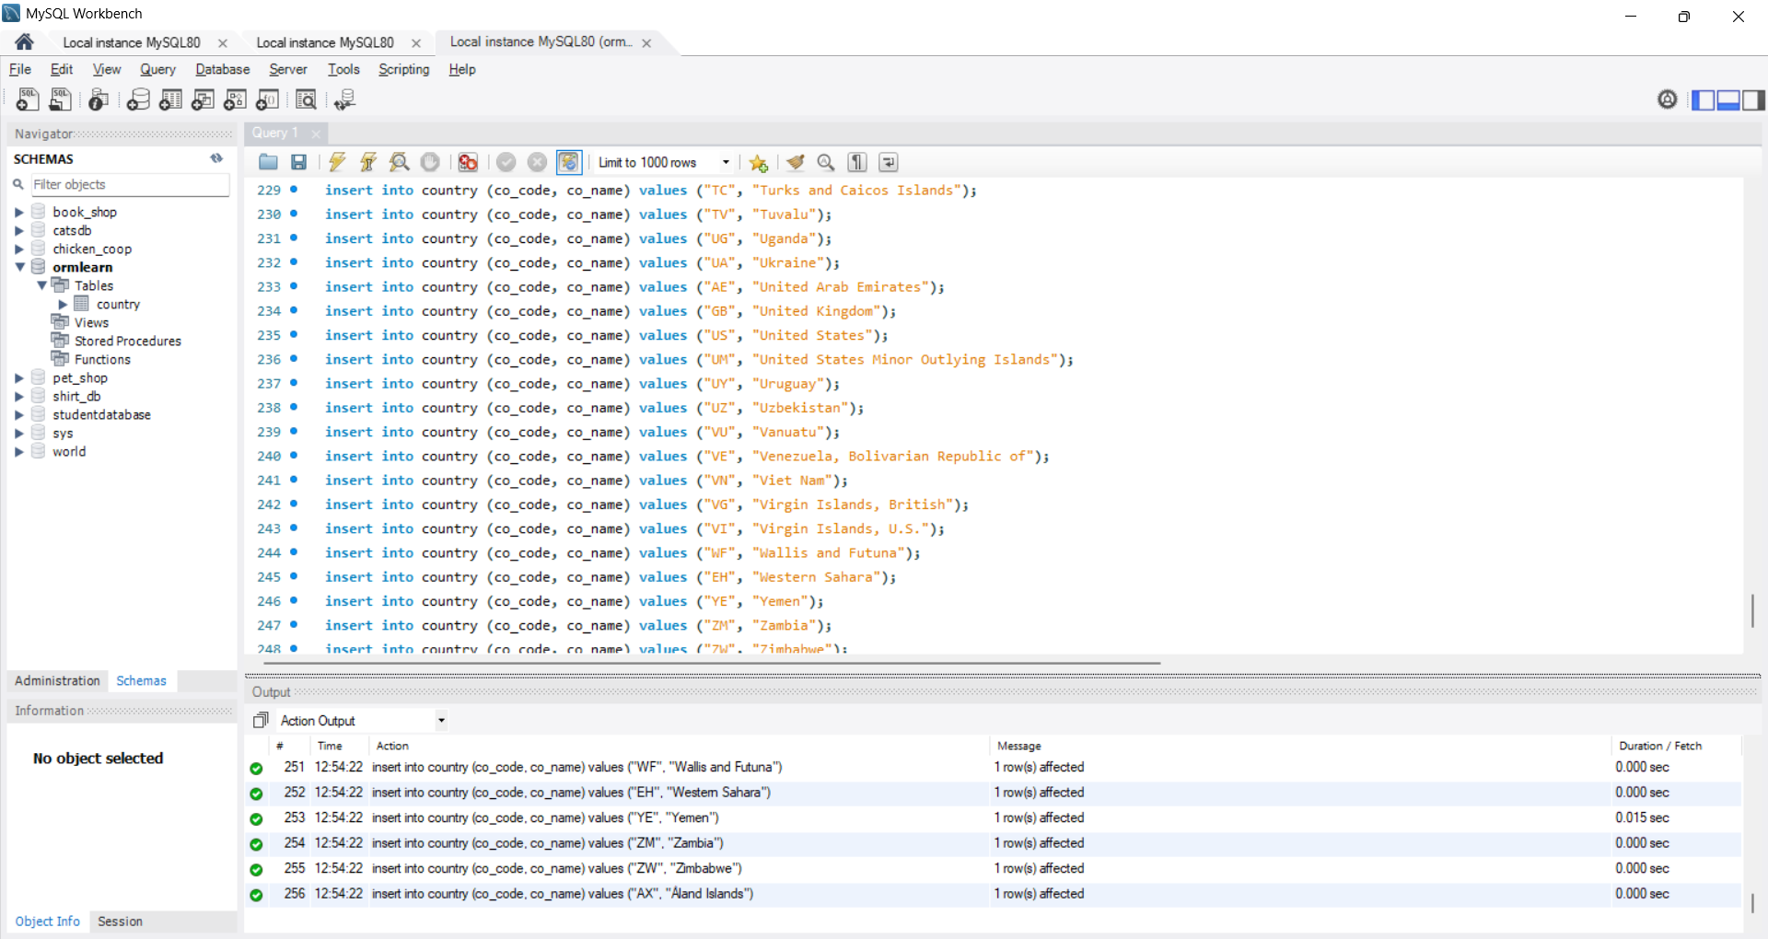

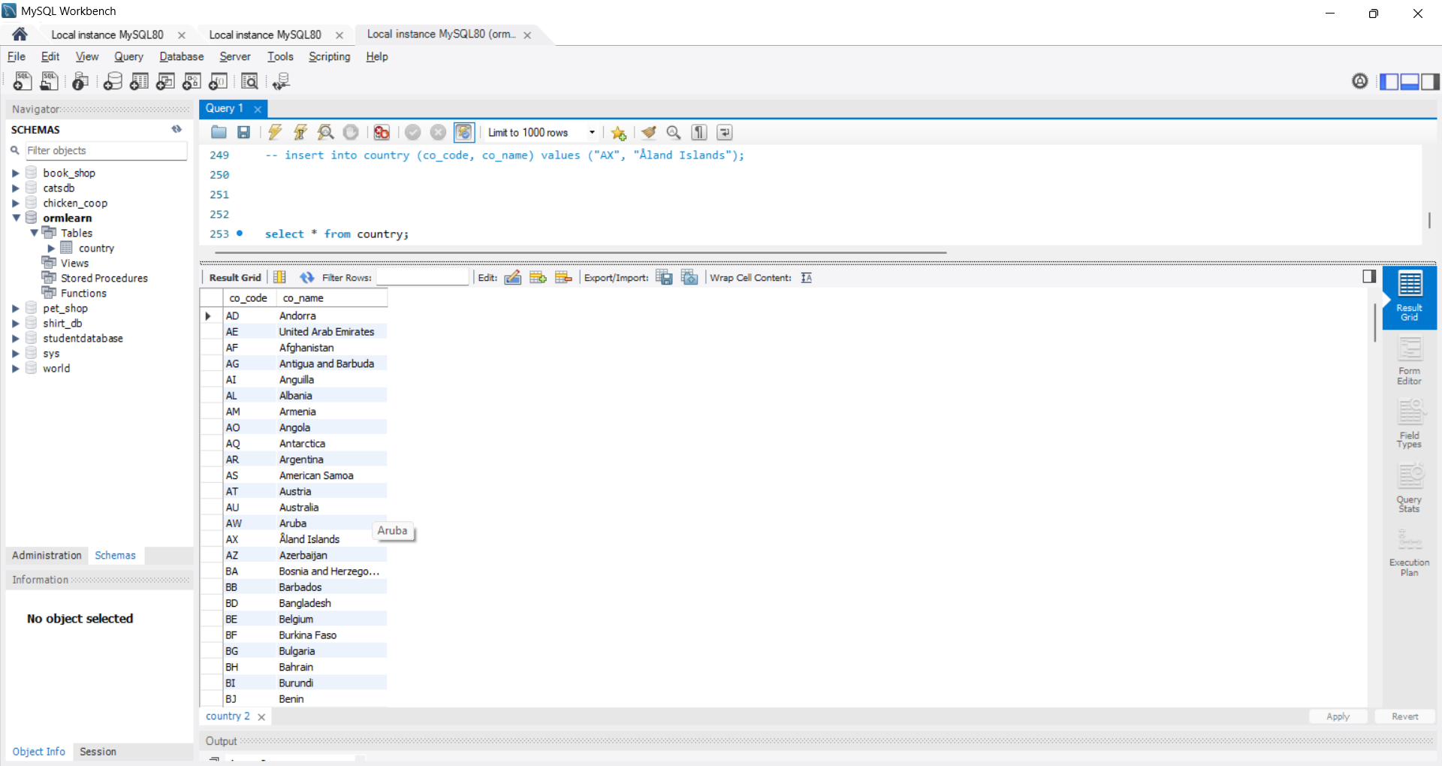

**Hands on 6**

**Find a country based on country code**

**Create new exception class CountryNotFoundException in com.cognizant.spring-learn.service.exception:**

**CountryNotFoundException.java**

package com.cognizant.orm_learn.service.exception;

public class CountryNotFoundException extends Exception {

public CountryNotFoundException(String message) {

super(message);

}

}

**Create new method findCountryByCode() in CountryService with @Transactional annotation**

**CountryService.java**

package com.cognizant.orm_learn.service;

import java.util.List;

import java.util.Optional;

import org.springframework.beans.factory.annotation.Autowired;

import org.springframework.stereotype.Service;

import com.cognizant.orm_learn.model.Country;

import com.cognizant.orm_learn.repository.CountryRepository;

import com.cognizant.orm_learn.service.exception.CountryNotFoundException;

import jakarta.transaction.Transactional;

*@Service*

public class CountryService {

*@Autowired*

private CountryRepository countryRepository;

public List<Country> getAllCountries() {

return countryRepository.findAll();

}

*@Transactional*

public Country findCountryByCode(String countryCode) throws CountryNotFoundException {

Optional<Country> result = countryRepository.findById(countryCode);

if (!result.isPresent()) {

throw new CountryNotFoundException("Country with code " + countryCode + " not found");

}

return result.get();

}

}

**OrmLearnApplication.java**

package com.cognizant.orm_learn;

import org.slf4j.Logger;

import org.slf4j.LoggerFactory;

import org.springframework.boot.SpringApplication;

import org.springframework.boot.autoconfigure.SpringBootApplication;

import org.springframework.context.ApplicationContext;

import com.cognizant.orm_learn.model.Country;

import com.cognizant.orm_learn.service.CountryService;

import com.cognizant.orm_learn.service.exception.CountryNotFoundException;

*@SpringBootApplication*

public class OrmLearnApplication {

private static CountryService *countryService*;

private static final Logger ***LOGGER*** = LoggerFactory.*getLogger*(OrmLearnApplication.class);

private static void testFindCountryByCode() {

***LOGGER***.info("Start");

try {

Country country = *countryService*.findCountryByCode("IN");

***LOGGER***.debug("Country: {}", country);

} catch (CountryNotFoundException e) {

***LOGGER***.error("Exception: {}", e.getMessage());

}

***LOGGER***.info("End");

}

public static void main(String[] args) {

ApplicationContext context = SpringApplication.*run*(OrmLearnApplication.class, args);

*countryService* = context.getBean(CountryService.class);

***LOGGER***.info("Inside main");

*testFindCountryByCode*();

}

}

**Output:**

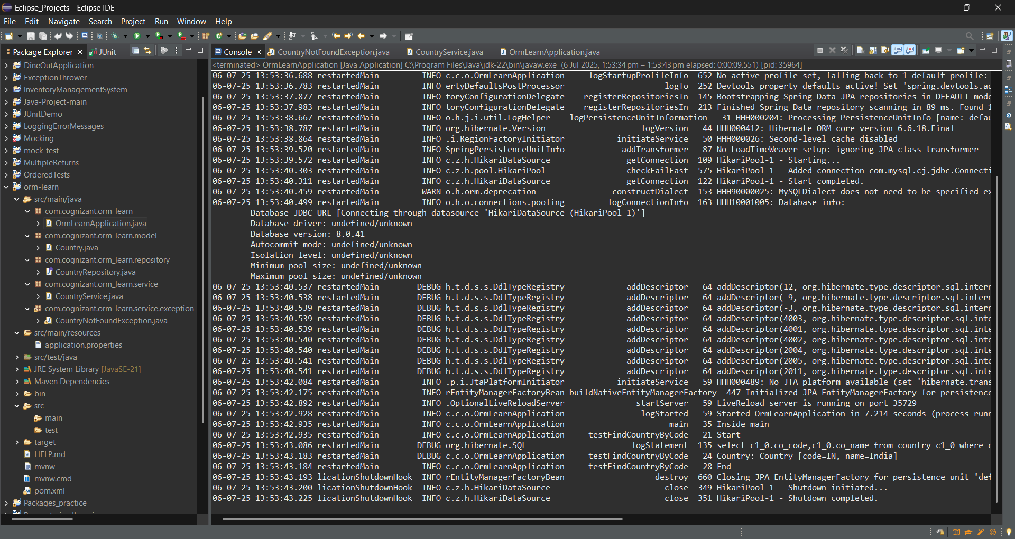

**Hands on 7**

**Add a new country** 

**Create new method in CountryService.**

**CountryService.java**

package com.cognizant.orm_learn.service;

import java.util.List;

import java.util.Optional;

import org.springframework.beans.factory.annotation.Autowired;

import org.springframework.stereotype.Service;

import com.cognizant.orm_learn.model.Country;

import com.cognizant.orm_learn.repository.CountryRepository;

import com.cognizant.orm_learn.service.exception.CountryNotFoundException;

import jakarta.transaction.Transactional;

*@Service*

public class CountryService {

*@Autowired*

private CountryRepository countryRepository;

public List<Country> getAllCountries() {

return countryRepository.findAll();

}

*@Transactional*

public Country findCountryByCode(String countryCode) throws CountryNotFoundException {

Optional<Country> result = countryRepository.findById(countryCode);

if (!result.isPresent()) {

throw new CountryNotFoundException("Country with code " + countryCode + " not found");

}

return result.get();

}

*@Transactional*

public void addCountry(Country country) {

countryRepository.save(country);

}

}

**Include new testAddCountry() method in OrmLearnApplication.**

**OrmLearnApplication.java**

package com.cognizant.orm_learn;

import org.slf4j.Logger;

import org.slf4j.LoggerFactory;

import org.springframework.boot.SpringApplication;

import org.springframework.boot.autoconfigure.SpringBootApplication;

import org.springframework.context.ApplicationContext;

import com.cognizant.orm_learn.model.Country;

import com.cognizant.orm_learn.service.CountryService;

import com.cognizant.orm_learn.service.exception.CountryNotFoundException;

*@SpringBootApplication*

public class OrmLearnApplication {

private static CountryService *countryService*;

private static final Logger ***LOGGER*** = LoggerFactory.*getLogger*(OrmLearnApplication.class);

private static void testFindCountryByCode() {

***LOGGER***.info("Start");

try {

Country country = *countryService*.findCountryByCode("IN");

***LOGGER***.debug("Country: {}", country);

} catch (CountryNotFoundException e) {

***LOGGER***.error("Exception: {}", e.getMessage());

}

***LOGGER***.info("End");

}

private static void testAddCountry() {

***LOGGER***.info("Start");

Country newCountry = new Country();

newCountry.setCode("XY");

newCountry.setName("Xyland");

*countryService*.addCountry(newCountry);

try {

Country fetched = *countryService*.findCountryByCode("XY");

***LOGGER***.debug("Fetched Country: {}", fetched);

} catch (CountryNotFoundException e) {

***LOGGER***.error("Country not found after adding");

}

***LOGGER***.info("End");

}

public static void main(String[] args) {

ApplicationContext context = SpringApplication.*run*(OrmLearnApplication.class, args);

*countryService* = context.getBean(CountryService.class);

***LOGGER***.info("Inside main");

*testFindCountryByCode*();

*testAddCountry*();

}

}

**Output**:

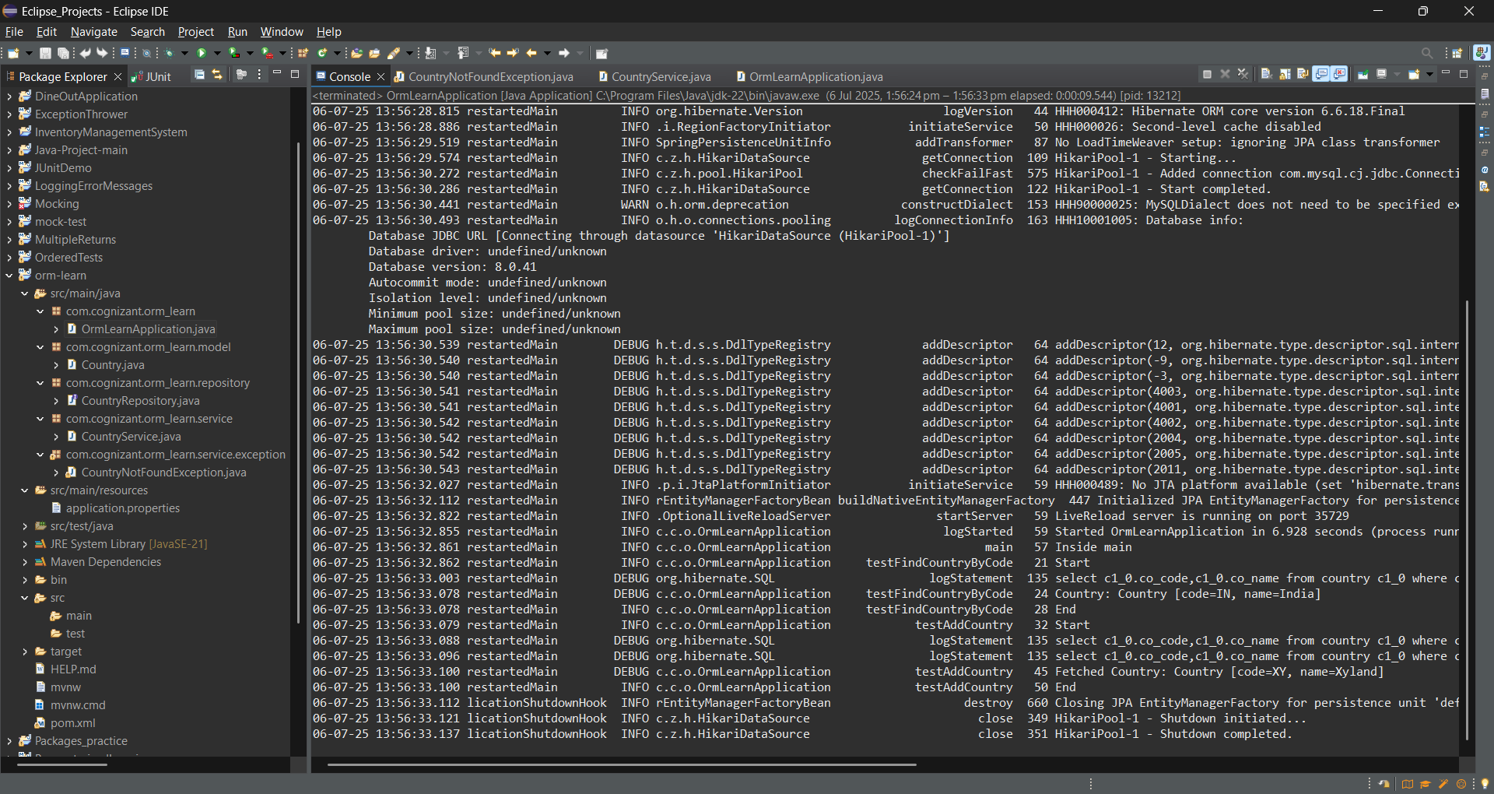

**Hands on 8**

**Update a country based on code** 

**Create a new method updateCountry() in CountryService with parameters code and name.**

**CountryService.java**

package com.cognizant.orm_learn.service;

import java.util.List;

import java.util.Optional;

import org.springframework.beans.factory.annotation.Autowired;

import org.springframework.stereotype.Service;

import com.cognizant.orm_learn.model.Country;

import com.cognizant.orm_learn.repository.CountryRepository;

import com.cognizant.orm_learn.service.exception.CountryNotFoundException;

import jakarta.transaction.Transactional;

*@Service*

public class CountryService {

*@Autowired*

private CountryRepository countryRepository;

public List<Country> getAllCountries() {

return countryRepository.findAll();

}

*@Transactional*

public Country findCountryByCode(String countryCode) throws CountryNotFoundException {

Optional<Country> result = countryRepository.findById(countryCode);

if (!result.isPresent()) {

throw new CountryNotFoundException("Country with code " + countryCode + " not found");

}

return result.get();

}

*@Transactional*

public void addCountry(Country country) {

countryRepository.save(country);

}

*@Transactional*

public void updateCountry(String code, String name) throws CountryNotFoundException {

Optional<Country> optionalCountry = countryRepository.findById(code);

if (!optionalCountry.isPresent()) {

throw new CountryNotFoundException("Country with code " + code + " not found.");

}

Country country = optionalCountry.get();

country.setName(name);

countryRepository.save(country);

}

}

**Include new test method in OrmLearnApplication, which invokes updateCountry() method in CountryService passing a country's code and different name for the country.**

**OrmLearnApplication.java**

package com.cognizant.orm_learn;

import org.slf4j.Logger;

import org.slf4j.LoggerFactory;

import org.springframework.boot.SpringApplication;

import org.springframework.boot.autoconfigure.SpringBootApplication;

import org.springframework.context.ApplicationContext;

import com.cognizant.orm_learn.model.Country;

import com.cognizant.orm_learn.service.CountryService;

import com.cognizant.orm_learn.service.exception.CountryNotFoundException;

*@SpringBootApplication*

public class OrmLearnApplication {

private static CountryService *countryService*;

private static final Logger ***LOGGER*** = LoggerFactory.*getLogger*(OrmLearnApplication.class);

private static void testFindCountryByCode() {

***LOGGER***.info("Start");

try {

Country country = *countryService*.findCountryByCode("IN");

***LOGGER***.debug("Country: {}", country);

} catch (CountryNotFoundException e) {

***LOGGER***.error("Exception: {}", e.getMessage());

}

***LOGGER***.info("End");

}

private static void testAddCountry() {

***LOGGER***.info("Start");

Country newCountry = new Country();

newCountry.setCode("XY");

newCountry.setName("Xyland");

*countryService*.addCountry(newCountry);

try {

Country fetched = *countryService*.findCountryByCode("XY");

***LOGGER***.debug("Fetched Country: {}", fetched);

} catch (CountryNotFoundException e) {

***LOGGER***.error("Country not found after adding");

}

***LOGGER***.info("End");

}

private static void testUpdateCountry() {

***LOGGER***.info("Start");

try {

*countryService*.updateCountry("IN", "Bharat");

Country updated = *countryService*.findCountryByCode("IN");

***LOGGER***.debug("Updated Country: {}", updated);

} catch (CountryNotFoundException e) {

***LOGGER***.error("Exception: {}", e.getMessage());

}

***LOGGER***.info("End");

}

public static void main(String[] args) {

ApplicationContext context = SpringApplication.*run*(OrmLearnApplication.class, args);

*countryService* = context.getBean(CountryService.class);

***LOGGER***.info("Inside main");

*testFindCountryByCode*();

*testAddCountry*();

*testUpdateCountry*();

}

}

**Output:**

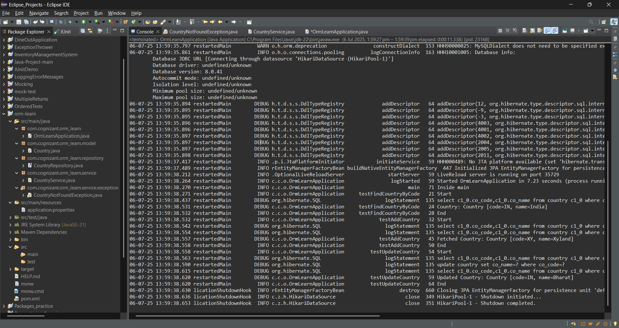

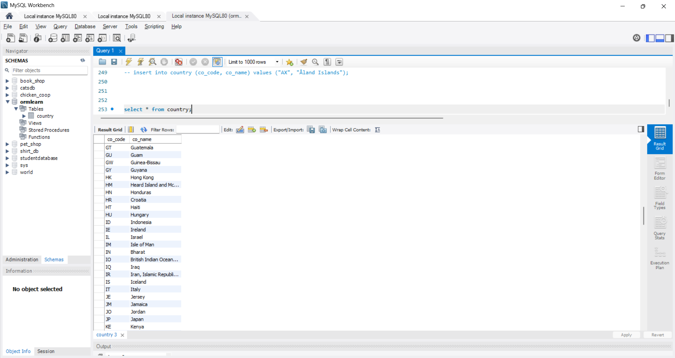

**Hands on 9**

**Delete a country based on code** 

**Create new method deleteCountry() in CountryService. Annotate this method with @Transactional.**

**CountryService.java**

package com.cognizant.orm_learn.service;

import java.util.List;

import java.util.Optional;

import org.springframework.beans.factory.annotation.Autowired;

import org.springframework.stereotype.Service;

import com.cognizant.orm_learn.model.Country;

import com.cognizant.orm_learn.repository.CountryRepository;

import com.cognizant.orm_learn.service.exception.CountryNotFoundException;

import jakarta.transaction.Transactional;

*@Service*

public class CountryService {

*@Autowired*

private CountryRepository countryRepository;

public List<Country> getAllCountries() {

return countryRepository.findAll();

}

*@Transactional*

public Country findCountryByCode(String countryCode) throws CountryNotFoundException {

Optional<Country> result = countryRepository.findById(countryCode);

if (!result.isPresent()) {

throw new CountryNotFoundException("Country with code " + countryCode + " not found");

}

return result.get();

}

*@Transactional*

public void addCountry(Country country) {

countryRepository.save(country);

}

*@Transactional*

public void updateCountry(String code, String name) throws CountryNotFoundException {

Optional<Country> optionalCountry = countryRepository.findById(code);

if (!optionalCountry.isPresent()) {

throw new CountryNotFoundException("Country with code " + code + " not found.");

}

Country country = optionalCountry.get();

country.setName(name);

countryRepository.save(country);

}

*@Transactional*

public void deleteCountry(String code) throws CountryNotFoundException {

if (!countryRepository.existsById(code)) {

throw new CountryNotFoundException("Country with code " + code + " not found.");

}

countryRepository.deleteById(code);

}

}

**Include new test method in OrmLearnApplication with following steps.**

**OrmLearnApplication.java**

package com.cognizant.orm_learn;

import org.slf4j.Logger;

import org.slf4j.LoggerFactory;

import org.springframework.boot.SpringApplication;

import org.springframework.boot.autoconfigure.SpringBootApplication;

import org.springframework.context.ApplicationContext;

import com.cognizant.orm_learn.model.Country;

import com.cognizant.orm_learn.service.CountryService;

import com.cognizant.orm_learn.service.exception.CountryNotFoundException;

*@SpringBootApplication*

public class OrmLearnApplication {

private static CountryService *countryService*;

private static final Logger ***LOGGER*** = LoggerFactory.*getLogger*(OrmLearnApplication.class);

private static void testFindCountryByCode() {

***LOGGER***.info("Start");

try {

Country country = *countryService*.findCountryByCode("IN");

***LOGGER***.debug("Country: {}", country);

} catch (CountryNotFoundException e) {

***LOGGER***.error("Exception: {}", e.getMessage());

}

***LOGGER***.info("End");

}

private static void testAddCountry() {

***LOGGER***.info("Start");

Country newCountry = new Country();

newCountry.setCode("XY");

newCountry.setName("Xyland");

*countryService*.addCountry(newCountry);

try {

Country fetched = *countryService*.findCountryByCode("XY");

***LOGGER***.debug("Fetched Country: {}", fetched);

} catch (CountryNotFoundException e) {

***LOGGER***.error("Country not found after adding");

}

***LOGGER***.info("End");

}

private static void testUpdateCountry() {

***LOGGER***.info("Start");

try {

*countryService*.updateCountry("IN", "Bharat");

Country updated = *countryService*.findCountryByCode("IN");

***LOGGER***.debug("Updated Country: {}", updated);

} catch (CountryNotFoundException e) {

***LOGGER***.error("Exception: {}", e.getMessage());

}

***LOGGER***.info("End");

}

private static void testDeleteCountry() {

***LOGGER***.info("Start");

try {

*countryService*.deleteCountry("NZ");

***LOGGER***.debug("Country deleted successfully.");

} catch (CountryNotFoundException e) {

***LOGGER***.error("Exception: {}", e.getMessage());

}

***LOGGER***.info("End");

}

public static void main(String[] args) {

ApplicationContext context = SpringApplication.*run*(OrmLearnApplication.class, args);

*countryService* = context.getBean(CountryService.class);

***LOGGER***.info("Inside main");

*testFindCountryByCode*();

*testAddCountry*();

*testUpdateCountry*();

*testDeleteCountry*();

}

}

**Output:**

